M03 Chapter 6 Hands On Submission

- Hands On Project 6-1 using trace file
  - Screenshot showing packets filtered as icmpv6.type == 133 with a packet expanded to show the contents
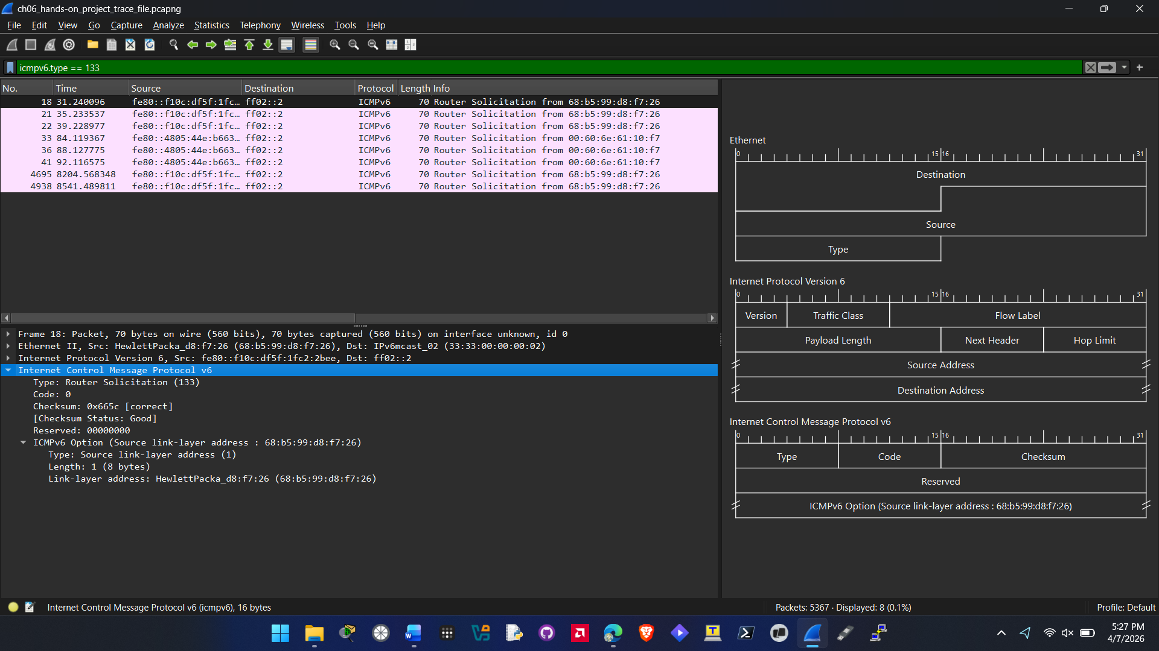
  - Screenshot showing packets filtered as icmpv6.type == 134 with a packet expanded to show the contents
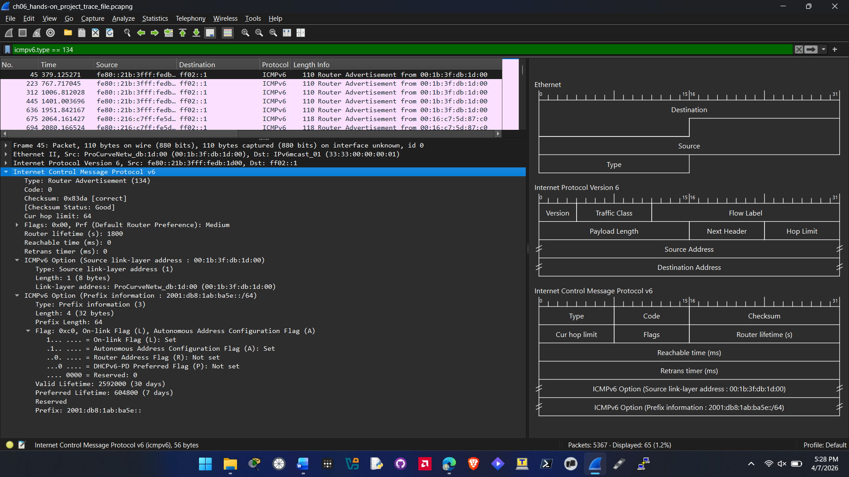
  - Screenshot showing packets filtered as icmpv6.type == 135 with a packet expanded to show the contents
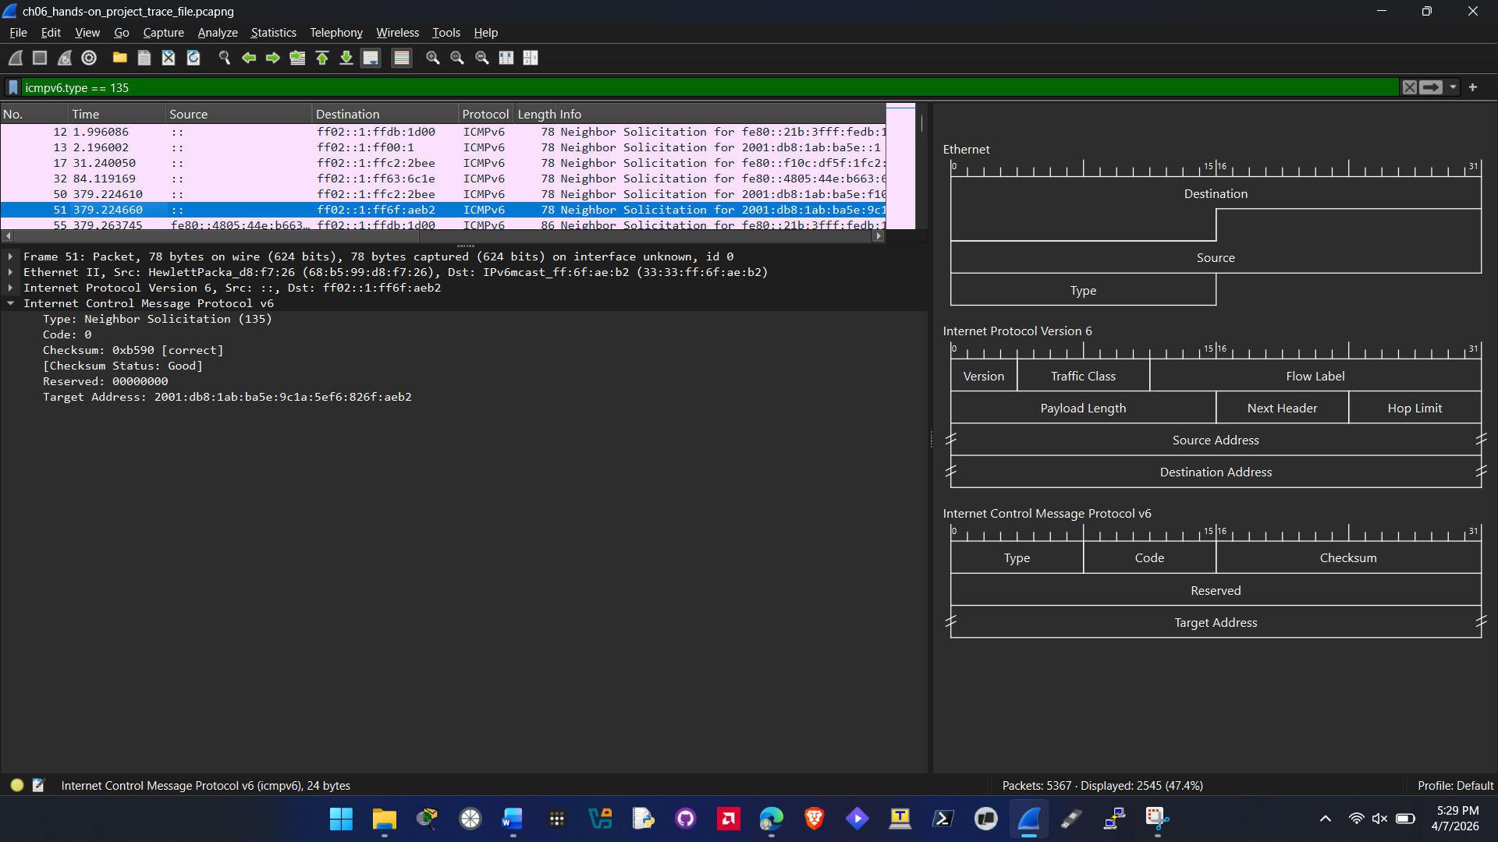
  - Screenshot showing packets filtered as icmpv6.type == 136 with a packet expanded to show the contents
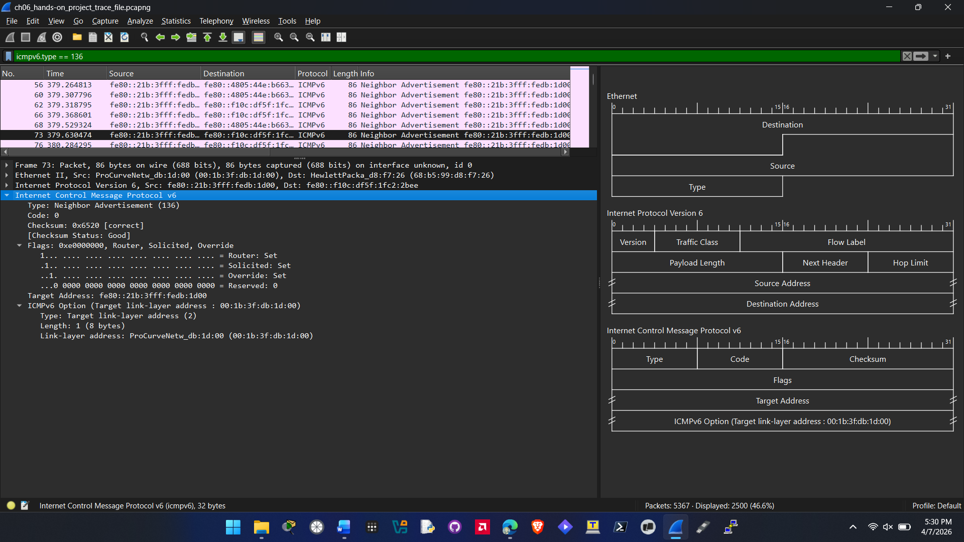

- Hands On Project 6-2
  - Screenshot showing packets filtered as icmpv6.type == 136 && ipv6.addr == fe80::4805:44e:b663:6c1e with a packet expanded to show the contents
